|  |  |
| --- | --- |
|  | **Year 11 General Biology**  **Task 6 – Cells Processes** |

|  |  |  |  |
| --- | --- | --- | --- |
| **Name:** | **Teacher:** | **Date:** | **Score: /51** |

**Assessment type:** Test

**Conditions**

Time for the task: 50 minutes

**Task weighting** – 10%

Total 51 marks

__________________________________________________________________________

|  |  |  |  |  |
| --- | --- | --- | --- | --- |
|  | Section | Number of questions | Marks available | Marks achieved |
| A | Multiple choice | 17 | 17 |  |
| B | Short answer | 9 | 26 |  |
| C | Extended answer | 2 | 8 |  |
|  | Total | 28 | 51 |  |

Comments:

**Part A: Multiple-choice (17 marks)**

Section A consists of 15 questions, each worth one mark. Each question has only one correct answer. Circle the correct answer. Attempt all questions. Marks will not be deducted for incorrect answers. You are advised to spend no more than 20 minutes on this section.

1. Looking at a cell under a microscope, you note that it is a prokaryote. How do you know?

|  |  |
| --- | --- |
| a. | The cell lacks cytoplasm. |
| b. | The cell lacks a cell membrane. |
| c. | The cell lacks a nucleus. |
| d. | The cell lacks genetic material. |

2. Which organelle is the powerhouse of the cell?

|  |  |
| --- | --- |
| a. | chloroplast |
| b. | golgi apparatus |
| c. | endoplasmic reticulum |
| d. | mitochondrion |

3. Which of the following is a function of the nucleus?

|  |  |
| --- | --- |
| a. | stores DNA |
| b. | stores sugars |
| c. | builds proteins |
| d. | packages proteins |

4. This micrograph (picture taken through a microscope) probably shows what type of cell?

a) plant

b) animal

c) bacteria

d) virus

5. In vascular plants, _____________ transports water and minerals from the roots to the rest of the plant.

1. xylem
2. phloem
3. cotyledons
4. sepals

6. Where does gas exchange occur in animals?

1. Left Broncus
2. Trachea
3. Alveoli
4. Terminal Bronchiole

7. Photosynthesis in green plants only occurs when the plant is in the light. When does respiration occur in green plants?

a) Only in the dark

b) At all times

c) Only in the light

d) When sufficient ATP is present

8. An enzyme is

a) a protein catalyst

b) under the direct control of ribosomes

c) a substance that increases Activation energy

d) none of the above

9. Which of the following is not directly needed by plants for photosynthesis?

1. carbon dioxide
2. bacteria
3. light
4. water

10. The green pigment in a plant is called ___________.

1. Chlorophyll
2. Chlorine
3. Mitochondria
4. Mesophyll

11. Which of these transports blood toward the heart?

1. aorta
2. capillaries
3. veins
4. blood vessels

12. What is the term that is best described as the diffusion of water through a selectively permeable membrane?

1. Diffusion
2. Osmosis
3. Water transfer
4. All of the above

13. All of the following are parts of the equation for cellular respiration, EXCEPT _____________.

1. glucose
2. oxygen
3. carbon dioxide
4. ADP

14. What is the function of plant roots?

1. to collect sunlight
2. to absorb nutrients from the soil
3. to produce flowers for reproduction
4. to eliminate wastes from the leaves

15. What is the role of the respiratory system?

a) To take in air and extract oxygen from it

b) To take in air and extract carbon dioxide from it

c) It the series of chemical changes that take place in cells to release energy

d). All of the above

Use the following diagram to answer questions 16 and 17.

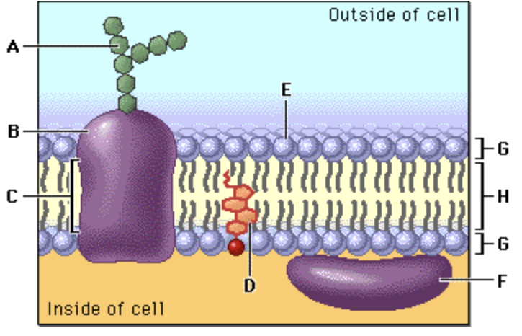

16. In the diagram, structure E corresponds to:

1. Protein
2. Carbohydrate
3. Lipid layer
4. A hydrophilic structure

17. In the diagram above, structure H corresponds to:

a) A hydrophobic structure

b) Cholesterol

c) An integral protein

d) A hydrophilic structure

**END OF MULTIPLE CHOICE QUESTIONS**

**Part B: Short answer (34 marks)**

Answer all questions in the spaces provided.

__________________________________________________________________________

Section B consists of 8 questions. Write your answers in the spaces provided. You are advised to spend 30 minutes on this section.

1. The diagram below shows part of an electron microscope image of a cell.

Organelle A

a) Is it Plant or Animal? ___________________________________________________ (1 mark)

b) Label the parts of the cell. (3.5 marks)

c) Name organelle (**A**). If organelle (**A**) was removed from the cell without excessive damage, what effect would this have on the function of the cell. (2 marks)

_________________________________________________________________________________________________________________________________________________________________________________________________________________________________

2. Based on your understanding of the characteristics of Plant and Animal cells, list three ways that Plant & Animal cell are different. (1.5 marks)

_________________________________________________________________________________________________________________________________________________________________________________________________________________________________

3. Identify the functions of the following the following organelles. (2 marks)

|  |  |
| --- | --- |
| ORGANELLE | FUNCTION |
| Cell Membrane |  |
| Cytoplasm |  |

4. Define the following: (2 marks)

Facilitated Diffusion ______________________________________________________________________________________________________________________________________________________

Catabolic reactions

______________________________________________________________________________________________________________________________________________________

5. What is the function of the Circulatory system? (1 mark)

_________________________________________________________________________________________________________________________________________________________________________________________________________________________________

6. Describe **how** surface area to volume ratio can affect the rate of diffusion of different types of substances across membranes. (2 marks)

_________________________________________________________________________________________________________________________________________________________________________________________________________________________________

7. Describe what has happened in the diagram below. (2 marks)

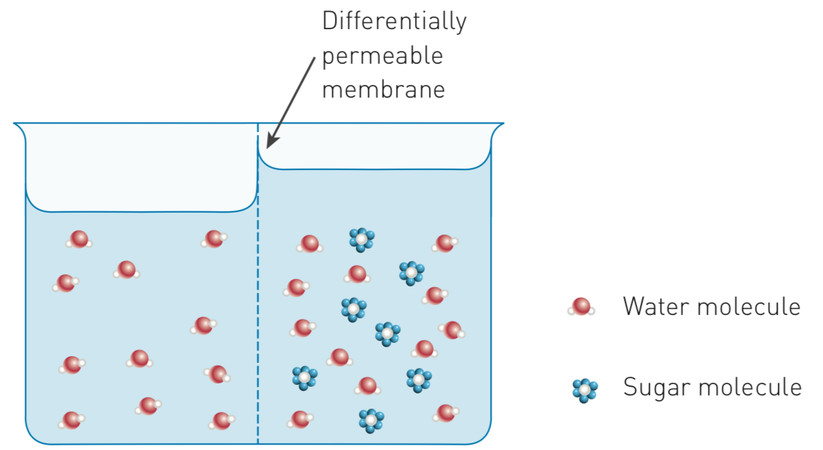

________________________________________________________________________________________________________________________________________________________________________________________________________________________________________________________________________________________________________________________________________________________________________________________________________________

8. The transportation of sugars and water within plants is essential for life. On the diagram of a tree below, use a blue pen to draw arrows to show the direction of water movement. Use a red pen to draw arrows to show the direction of sugar movement.

(1 mark)



9. Photosynthesis is a series of chemical reactions catalyzed by enzymes that occurs in the chloroplasts of plant cells.



a) Write a word equation for PHOTOSYNTHESIS. (2 marks)

________________________________________________________________________________________________________________________________________________________________________________________________________________________

10.

a) Write a word equation for RESPIRATION. (2 marks)

________________________________________________________________________________________________________________________________________________

c) A man was training for a 15 km fun run. He noticed that after 10 km his legs started to ache. Explain what is happening inside his muscle cells. (2 marks)

________________________________________________________________________________________________________________________________________________________________________________________________________________________________________________________________________________________________

d) What is the main difference between AEROBIC and ANAEROBIC respiration?

(2 marks)

________________________________________________________________________________________________________________________________________________________________________________________________________________________________________________________________________________________________

END OF SHORT ANSWER QUESTIONS

**Section C: Short Answer (8 marks)**

**Section C consists of 2 question**.

Write your answers in the spaces provided. You are advised to spend 10 minutes on this section.

1. A student set up the following experiment.



The experiment was left out on an open oval from 7:00 am to 5:00 pm on a sunny day. Explain the difference in the concentration of oxygen and carbon dioxide in the jars.

Oxygen concentration

________________________________________________________________________________________________________________________________________________________________________________________________________________________________________________________________________________________________________________________________________________________________________________________________________________________________________________________________________________________________________________________

Carbon dioxide concentration

________________________________________________________________________________________________________________________________________________

________________________________________________________________________________________________________________________________________________________________________________________________________________________________________________________________________________________________________________________________________________________________________

2. The cells below are erythrocytes (red blood corpuscles). Varying amounts of sucrose were added to the extracellular environments A, B and C. Each of the three pictures depicts them in a different extracellular environment.

Describe fully the **solutions** and the **processes** that occur in the stages shown at **A** and **C**.

(4 marks )

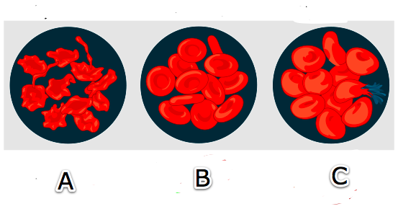

Stage A

____________________________________________________________________________________________________________________________________________________________________________________________________________________________________________________________________________________________

__________________________________________________________________________________________________________________________________________________________________________________________________________________________________________________________________________________________________________________________________________________________________________________________________________________________________________

______________________________________________________________________________________________________________________________________________

Stage C

____________________________________________________________________________________________________________________________________________________________________________________________________________________________________________________________________________________________

__________________________________________________________________________________________________________________________________________________________________________________________________________________________________________________________________________________________________________________________________________________________________________________________________________________________________________

______________________________________________________________________________________________________________________________________________

END OF TEST